Sokkia Receiver Utility (SRU) - Loading Radio Firmware
What You Will Need
- SRU Receiver Utility (SRU) installed on your PC or Field Controller
- Sokkia GPS Receiver with old firmware
- Updated Firmware for your Sokkia GPS Receiver

Loading Radio Firmware

Open Sokkia Receiver Utility and go to Firmware Loading. This can be done by navigating to Device -> Application Mode -> Firmware Loading.

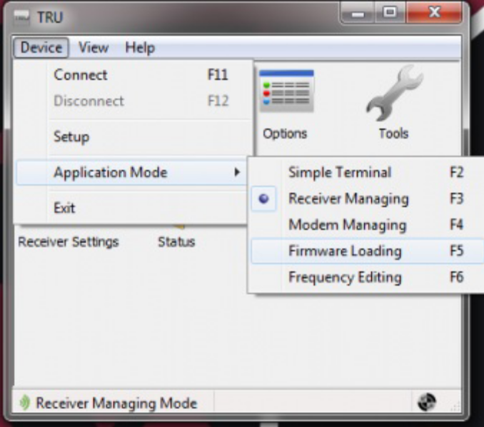

- Enter your connection parameters to the receiver and Click Connect.

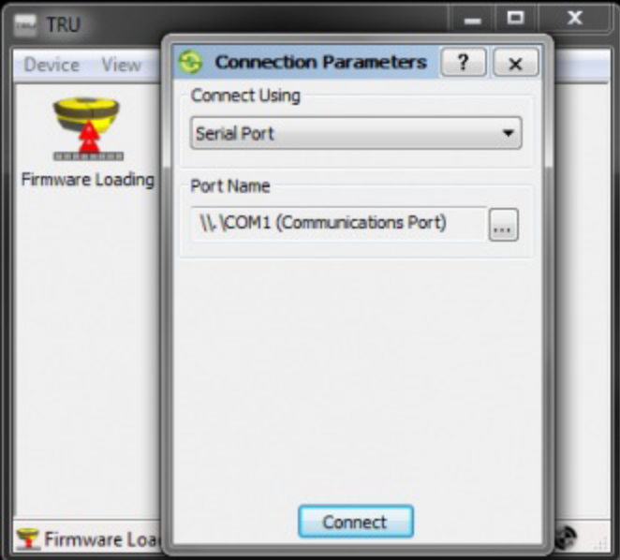

- Change the Device Type to Modem, as you are loading the radio firmware.
- Leave the default Modem Firmware Format as GNSS (.ldr, .ldp).
- Choose the Capture Method.

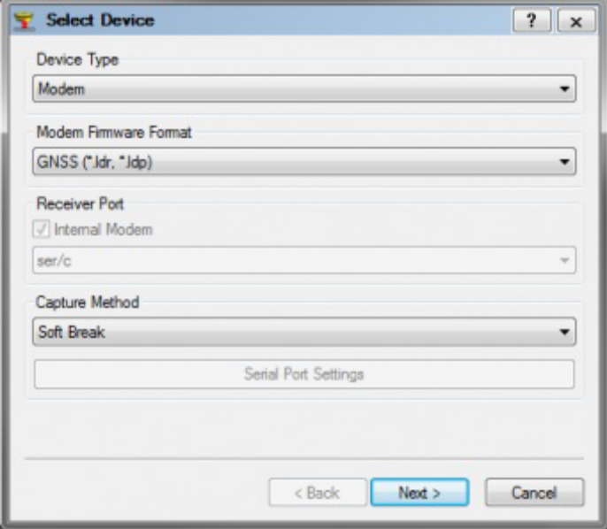

Note: Soft Break will connect to the unit while it is powered on and plugged in. Power On Capture requires you have the unit connected and power it on manually within the given time frame.

- Click Next
- Select the files to load by Clicking on the Folder Icon and navigating to where you have the radio firmware saved.

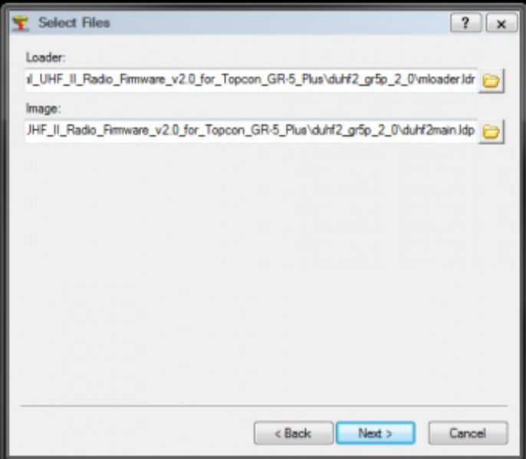

Note: The Loader file ends in “.ldr” and the Image file ends in “.ldp”

- Click Next.
- An information windows will pop up with what device type you are loading firmware to.
- Click Next.

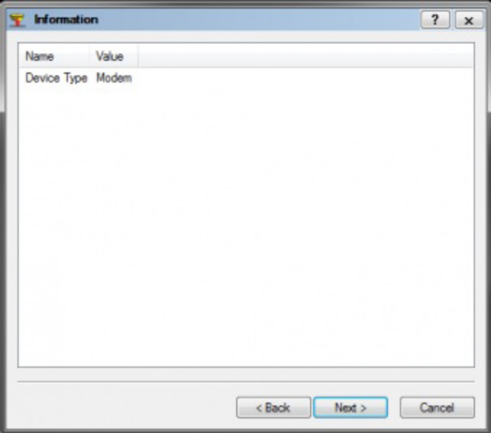

- The new firmware will begin writing to the receiver.

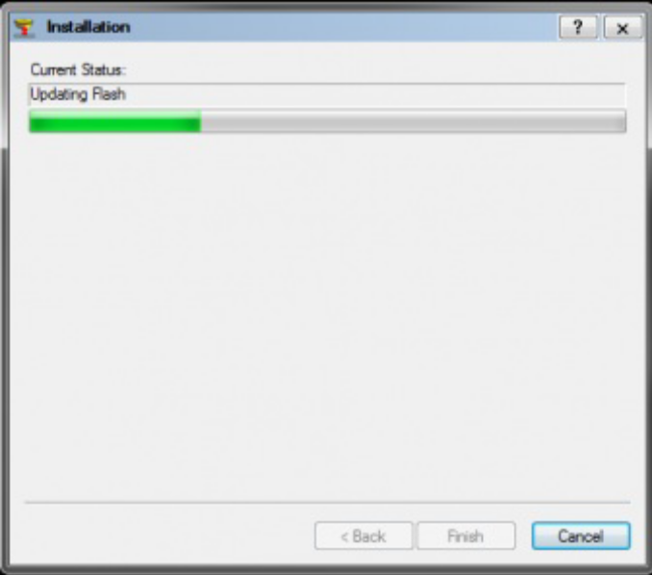

- A popup will appear indicating the firmware has been successfully updated.
- Click OK to exit firmware loading.

